**Media Player**

It is a device that enables the conversion of one type of media or signal to another. Used to connect different types of network cables or segments that use different physical media such as fiber optic cables and copper cable (Ethernet).

RX- Receiver

TX- Transmit

In a typical media converter setup, you'll have two cables connected: one for TX and one for RX.

For example, in a fiber-to-copper media converter, the TX port of the fiber connection sends data through the fiber cable, while the RX port receives data from the fiber cable.

These ports are usually paired, meaning the TX port on one device connects to the RX port on another device, and vice versa. This ensures that data can be sent and received correctly between the two connected devices.

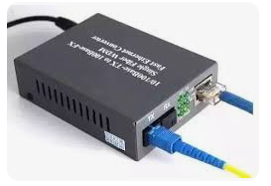

IP Addressing

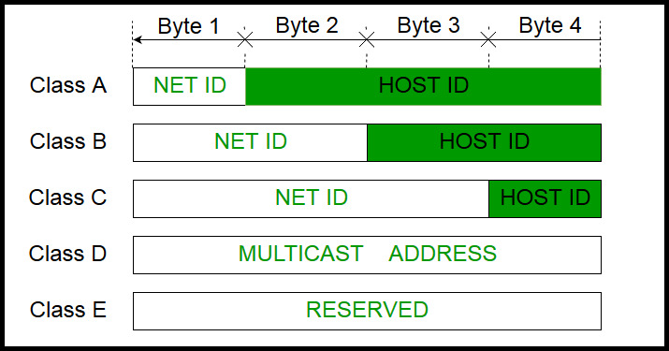

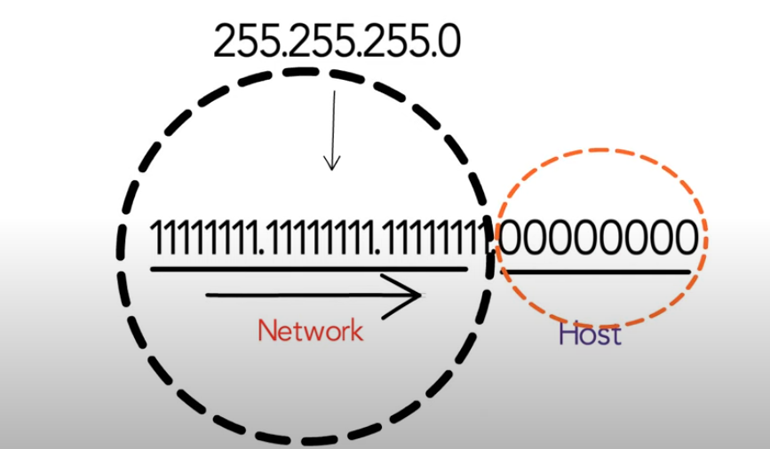

The 1’s in the subnet mask represent the network portion and 0’s represent the host portion.

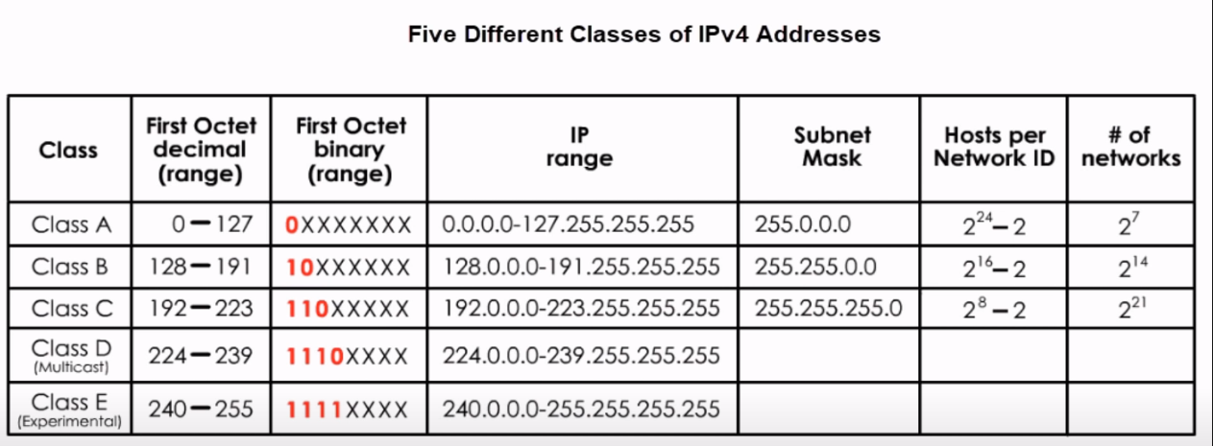

Example

192.168.123.132 /24 OR 255.255.255.0

255.255.255.0 = 11111111.11111111.11111111.00000000

IP address(192.168.123.132) 11000000.10101000.01111011.10000100

Subnet mask(255.255.255.0) 11111111.11111111.11111111.00000000

Network address /192.168.123.0 11000000.10101000.01111011.00000000

Host address (000.000.000.132) 00000000.00000000.00000000.10000100

Subnets = 2 power # of subnet bits

Valid hosts = 2 power # of host bits -2

Example

192.168.1.0

255.255.255.240 (/28)

11111111.11111111.11111111.11110000

Class C ip address so, Subnets = 2 power 4 = 16 (4 because of 1111)

Hosts = 2 power 4 -2 = 14 (4 because of 0000)